RM011 – SEARCHING FOR BOXES
- On the toolbar at the top of the FileMaster screen, click ‘FileMaster’ and select ‘File Enquiry’ from the drop-down menu.

Or you can type Ctrl + F (keyboard commands are indicated on the drop-down menu).

- The ‘Search’ box will appear.

Select a search option by clicking on the yellow box on the top left hand side. A drop down menu will appear.

- Select By Text using the mouse

- Select the ‘Comments’ field in the ‘Search In’ box as this is where the box numbers and barcodes are recorded in FileMaster.

- In the text entry box, type the box number you are looking for (eg SYS Box 12). You can also use this to check that the box you are about to create doesn’t already exist.

- Click on ‘Search’. If several files are contained in the box, a list will appear – the selection screen. If only one file is contained in the box, the File Screen will appear. If ‘No Match Found’ appears, then the box does not exist.

- When a list of files appears, it is a good idea to click on each file and check that the file is contained in that particular box.

To do this, you can either use the mouse, or click on the first file and use the cursor keys.

By doing this you can check the comments of the file without having to open the file itself.

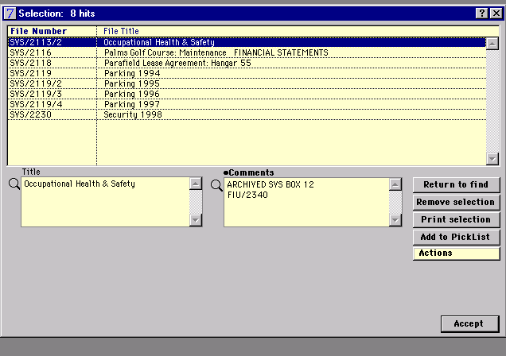

Sometimes, the list may include files that are not exactly what you were searching for. For example, if you search for SVS Box 2, you would also get SVS Box 20, and 200. You can limit the search by ticking the ‘Exact Match on Words’ option. However, we recommend that you check through the list as there may also be other words or numbers entered in the comments that may match your search criteria eg dates.

