Core Attributes of UniSA Staff
Descriptors for Professional Staff
 |  | Contents  - HEO1 - 4 descriptors  - HEO5 descriptors  - HEO6 & 7 descriptors  - HEO8 & 9 descriptors  - HEO10 descriptors  - Senior Staff descriptors | 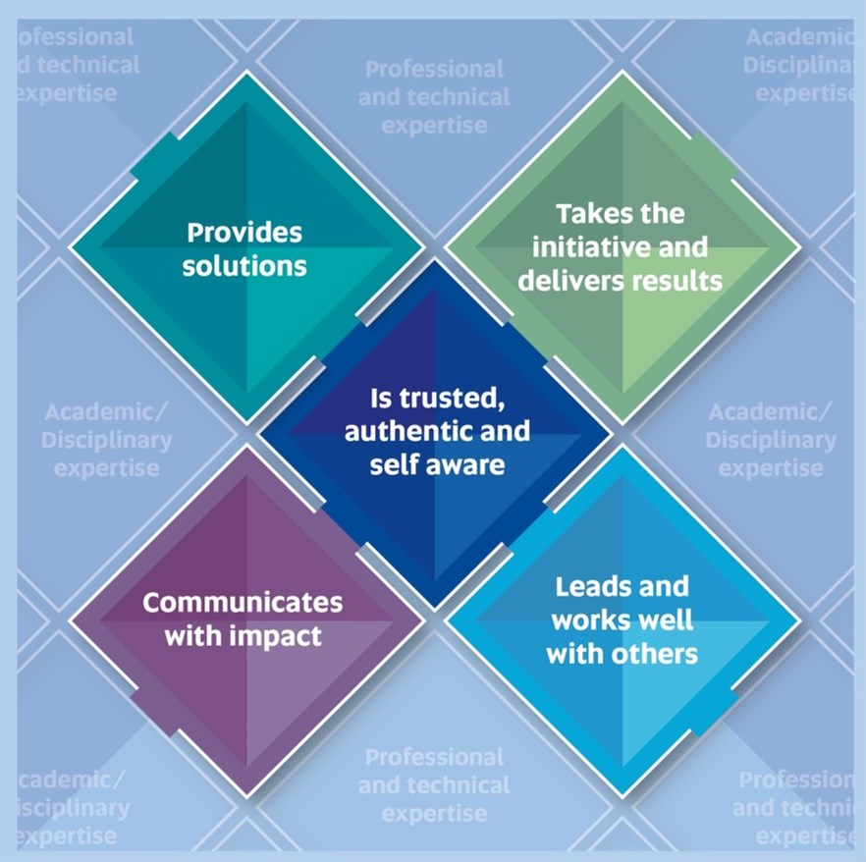
Core Attributes of UniSA Staff
Descriptors for Professional Staff (HEO1 - 4)
PROVIDES SOLUTIONS | COMMUNICATES WITH IMPACT | LEADS AND WORKS WELL  WITH OTHERS | TAKES THE INITIATIVE  AND DELIVERS RESULTS | IS TRUSTED, AUTHENTIC  AND SELF AWARE
- Seeks to understand and respond appropriately to client and staff needs and requirements and find ways to improve services.  - Seeks to anticipate possible problems and takes steps to minimise or eliminate risks.  - Is logical and methodical in his/her approach to problem solving and explores relevant sources to inform resolution.  - Considers problems and situations from different angles when initial efforts to solve problems fail.  - Recognises when to escalate an issue and the most appropriate point for its resolution and acts on this.  - Is able to cope with uncertainty and an incomplete set of facts and take action to seek clarity and further information to help develop a feasible and effective solution.  - Seeks to consider the wider impact of any actions on others. | - Written communication uses clear language and avoids jargon; contextualises information appropriately and grammar/usage problems are rare.  - Speaks openly and honestly; is diplomatic and tactful, showing respect and open-mindedness for others’ right to a different view.  - Takes action to keep self informed/up to date and takes the opportunity to practice different approaches to improve both written and oral communication skills.  - Practices attentive and active listening and has the patience to hear people out, and asks questions to test for clarity of understanding.  - Uses different communication media appropriately (e.g., e-mail, telephone, face to face meetings) and for greatest effect.  - Seeks to ensure that the timing of communication is effective and reaches the right audience. | - Consistently treats others in the same way as one would wish to be treated.  - Understands his/her role within a team, participates willingly and fulfils their designated role and responsibilities in the group.  - Takes responsibility for how his/her work and behaviour impacts on others.  - Seeks opportunities to work with others and to build positive and productive relationships to achieve shared objectives.  - Contributes to creating a positive and productive working environment.  - Openly shares information and values, calls upon and utilises the experience and expertise of colleagues; gives praise and credit when and where it is due.  - Acts constructively to counteract and address other's negative attitudes and behaviours. | - Performs and achieves to the best of his/her ability; and applies best efforts to honour commitments.  - Manages own time and workload effectively, and expectations of priorities, is reliable and gets planned work done within deadlines.  - Is determined to see things through to completion; pushes self and others for results.  - Is always open to trying new ways to do things to achieve effective and efficient work outcomes.  - Acts with the customer in mind and seeks to anticipate their needs.  - Willingly asks questions and makes suggestions for better ways of working or completing a task.  - Recognises when to act independently and when to seek advice.  - Takes a can-do approach in good and bad situations. | - Is fair, consistent, open and honest in dealings with and treatment of others.  - Takes pride in being trustworthy, keeps confidences and respects privacy.  - Is approachable, patient and does his/her best to relate well to all kinds of people.  - Seeks guidance and feedback when needed, is open to constructive criticism and admits mistakes.  - Strives to continuously learn, seeking work and development opportunities to improve the quality and scope of what they do.  - Tries to always remain composed and not be knocked off balance by the unexpected or lose cool under pressure or stress.  - Doesn't misrepresent him/herself for personal gain.

Core Attributes of UniSA Staff
Descriptors for Professional Staff (HEO5)
PROVIDES SOLUTIONS | COMMUNICATES WITH IMPACT | LEADS AND WORKS WELL  WITH OTHERS | TAKES THE INITIATIVE  AND DELIVERS RESULTS | IS TRUSTED, AUTHENTIC  AND SELF AWARE
- Acknowledges customer issues and accepts responsibility in resolution process.  - Maintains communication at an appropriate level to inform all key stakeholders of progress.  - Supports colleagues to perform their role by receiving, processing and analysing information and provides assistance to others in overcoming challenges.  - Identifies improvements to operational processes and procedures and recommends effective and sustainable changes.  - Applies theoretical principles and uses analytical methods and tools to solve problems.  - Seeks information and views from diverse sources and used these inputs to find solutions or complete work.  - Identifies stakeholders who can contribute to and benefit from decision making activities and takes steps to engage with them.  - Interprets policies and procedures to identify relevant facts and information before making decisions. | - Presents verbal and written communication in a clear, concise and accurate manner.  - Shares knowledge and information within timeliness in manners appropriate to particular audiences.  - Actively listens and asks questions to clarify own understanding.  - Uses sound judgement to determine the most effective method of communication in a range of situations with a variety of people.  - Effectively tailors information and own language to the target audience and individual needs.  - Creates long lasting relationships built on effective communication and trust with internal and external stakeholders.  - Identifies and develops practical, useful ways to obtain feedback to improve communication.  - Consistently adopts a sensitive and positive manner in interacting with others. | - Draws on experience and evaluates information to identify trends.  - Is positive in the face of set-backs and adversity.  - Works inside and outside of own team to share ideas and information, and actively seeks the ideas and suggestions of others.  - Responds positively to the needs of the team and embraces new opportunities.  - Actively participates in networks outside of their team.  - Builds and maintains effective relationships with colleagues and works effectively as a team member.  - Takes ownership of work and encourages others to accept responsibility for their work.  - Actively supports and assists team members to reach individual and team objectives. | - Actively establishes working relationships with all stakeholders.  - Maintains a working knowledge of procedural frameworks that apply to their position and understands how they connect with the broader organisation context.  - Accepts responsibility for own performance and delivers on time and to the required standard.  - Creatively brings together materials from different contexts.  - Challenges the norm and suggests different and original ways to deal with organisational problems and opportunities.  - Recognises that ambiguity exists within the workplace and is able to operate within ambiguous contexts.  - Considers new approaches or solutions to problems and demonstrates taking these forward, with consideration of impact on the work of others.  - Supports new ideas and initiatives with enthusiasm and demonstrates willingness to try unfamiliar tasks. | - Develops a strong work ethic and manages own workload autonomously.  - Recognises when to act independently and when to seek help.  - Actively seeks feedback, isn't defensive and gains insights from mistakes.  - Demonstrates self-control and recognises potential pressure points.  - Understands how their emotional responses to a situation influences how they are perceived.  - Critically listens to seek and understand differing perspectives.  - Recognises and acknowledges the emotions of others.  - Is open minded and guided by the desire to treat people equitably.

Core Attributes of UniSA Staff
Descriptors for Professional Staff (HEO6 & 7)
PROVIDES SOLUTIONS | COMMUNICATES WITH IMPACT | LEADS AND WORKS WELL  WITH OTHERS | TAKES THE INITIATIVE  AND DELIVERS RESULTS | IS TRUSTED, AUTHENTIC  AND SELF AWARE
- Demonstrates awareness of internal and external working relationships and how to gather information and promote solutions.  - Understands the impact of solutions on operational business, considers the broader organisational impact and mitigates risk.  - Independently identifies opportunities for improvement, and adapts procedures and/or techniques to be innovative and fit for purpose.  - Can anticipate and discuss the multiple impacts of issues using data, facts, opinion, anecdote and metaphor.  - Integrates desired organisational culture and values when developing and implementing solutions.  - Recognises and considers the optimal timing for broaching and/or implementing changes.  - Seeks input from internal and external sources to develop and refine new ideas and approaches. | - Communicates in an influential and articulate manner.  - Recognises communication is contextually based and adjusts style to suit audience and situation.  - Is open to the opinion of others and seeks to understand their position before giving feedback.  - Effectively uses a variety of communication methods when influencing outcomes, e.g. consultation, technology, written, oral, forums etc.  - Constructively and sensitively explains and communicates difficult and unpopular decisions when necessary.  - Considers the wider impact of projects on the business now and into the future.  - Uses understanding of group interactions to move towards a specific outcome.  - Seeks to understand what the audience should think, feel or do and adjusts communication to achieve the desired outcome. | - Inspires discretionary effort at individual and team level.  - Holds constructive conversations, seeking to clarify meaning and intent and provides opportunities for others input.  - "Encourages team to share constructive information and ideas to achieve common goals."  - Makes changes to improve personal performance.  - Establishes networks to expand knowledge and enhance outcomes.  - Operates outside comfort zone and embraces challenges.  - Encourages colleagues to embrace new ideas, bounce back after setbacks, pursue development opportunities and take responsibility for own work.  - Makes decisions and judgements fairly and equitably, exercising due care in setting precedents that have flow-on effects for the business or others. | - Actively influences stakeholders to sustain effective working relationships and deliver required outcomes.  - Uses judgement to select and navigate through the appropriate procedural framework(s).  - Acts to improve a situation without waiting for explicit direction.  - Holds self, and others, accountable for achieving required result.  - Treats mistakes as an opportunity to implement improvements, and encourages others to do the same.  - Able to effectively work despite obstacles and uncertainty and assists others in dealing with risk and working through ambiguity.  - Develops practical and realistic plans that ensure efficient use of resources.  - Proactively digs beneath the obvious. | - Is self-motivated with a high level of self-discipline.  - Adapts personal approach and behaviour to situations.  - Promotes a respectful and inclusive environment where unacceptable behaviours are challenged and people can be open about personal beliefs and feelings.  - Builds trust through modelling behaviours, admits mistakes and shortcomings.  - Views challenges as opportunities for growth.  - Is mindful of others' reactions and body language and to their own pre-set assumptions about others' behaviour.  - Presents the unvarnished truth in an appropriate and constructive manner.  - Owns mistakes and focuses on solutions rather than blame.

Core Attributes of UniSA Staff
Descriptors for Professional Staff (HEO8 & 9)
PROVIDES SOLUTIONS | COMMUNICATES WITH IMPACT | LEADS AND WORKS WELL  WITH OTHERS | TAKES THE INITIATIVE  AND DELIVERS RESULTS | IS TRUSTED, AUTHENTIC  AND SELF AWARE
- Anticipates needs, seeks to identify potential problems at a local and enterprise level and actively works towards an optimal solution.  - Freely shares knowledge and skills and visualises problems in a variety of ways to equip others in contributing to resolutions.  - Demonstrates and promotes the importance of identifying and managing risk through careful analysis and applies mitigation strategies across boundaries.  - Unpacks complex strategic problems by identifying hidden internal and external variables impacting people and the organisation to implement practical and sustainable solutions.  - Strengthens arguments and perspectives with sound thinking and critical analysis of multiple data sets.  - Makes timely and evidence based decisions responding to operational and organisational pressures and needs/changes.  - Establishes opportunities for collaboration on matters involving multiple (relevant) stakeholders internal and external to organisation, recognising and promoting the benefits of engagement.  - Negotiates skilfully in difficult situations and creates 'wins' without damaging relationships.  - Proposes sound recommendations for policy amendments. | - Consistently communicates complex matters clearly and concisely; coaches others to do so.  - Effectively communicates in a variety of formal/informal settings with multiple contextual factors.  - Communicates with poise and respect with senior management and people at all levels across the University and external parties.  - Delivers difficult messages through planning to achieve an effective outcome in a way that stimulates change of behaviour.  - Thinks through how to influence and develop communication with multiple strategic stakeholders.  - Uses personal and organisational knowledge to interpret and enhance the value of information for others.  - Changes tactics midstream when communication isn’t working (e.g. when audience is resistant). | - Drives unwavered commitment and passion for projects and initiatives, and inspires others to persist.  - "Communicates the University's vision and external influences, drawing relevance for team members and colleagues."  - Creates a climate in which people want to do their best, and are comfortable to step outside of their comfort zone.  - Brokers solutions with multiple parties to overcome internal (policy) and external (regulatory) challenges.  - Motivates at individual and team level and empowers others.  - Accurately scopes out length and difficulty of tasks, anticipates and adjusts for problems and roadblocks.  - Sets objectives with broad long term impact and monitors performance effectively via the performance management framework.  - Celebrates and promotes individual achievements, team and organisational successes.  - Consciously recognises and develops future leaders, exploiting strengths to achieve the big picture.  - Follows and shares emerging issues and industry trends. | - Initiates engagement with, and influences stakeholders to achieve outcomes aligned to business goals, that will promote the University's objectives.  - Encourages and empowers others to achieve required results within agreed timeline.  - Inspires a culture that embraces accountability.  - Drives effective, innovative solutions by stimulating discussions about creative problem solving.  - Reinforces the importance of informing decision making through a global industry lens to enable the University to confirm itself as an industry leader.  - Communicates clearly and comfortably despite ambiguity, and assists others to navigate through ambiguity.  - Pioneers opportunities for advancement through cost/benefit analysis, and appropriate mitigation, of identified risks.  - Is comfortable knowing that they are not always expected to have the answer. | - Promotes optimism and a positive work environment, inspiring good morale and co-operation.  - Exercises well-honed skills in sound judgement and making good decisions in high demand and challenging situations.  - Displays perseverance, encourages difference; recognises when self-interest is clouding perspectives.  - Upholds University values in own actions, recognises/rewards others for doing so, and displays courage in calling-out those who do not.  - Handles risk and uncertainty decisively; remains calm in stressful situations.  - Facilitates management of differences by addressing them openly and encouraging mutually beneficial resolutions.  - Acts as a trusted advisor, and mentor and inspires confidence.  - Knows and manages personal strengths, weaknesses, opportunities and limits.  - Demonstrates a genuine interest, and takes actions, in the development of others as well as self.

Core Attributes of UniSA Staff
Descriptors for Professional Staff (HEO10)
PROVIDES SOLUTIONS | COMMUNICATES WITH IMPACT | LEADS AND WORKS WELL  WITH OTHERS | TAKES THE INITIATIVE  AND DELIVERS RESULTS | IS TRUSTED, AUTHENTIC  AND SELF AWARE
- Works with information across, as well as within, business streams, seeing the broader picture and considers and integrates other opinions.  - Reviews the quality of decision-making within their area, explains data insights, and evaluates impact on the organisation.  - Considers current situations, future challenges, or ideas in the widest possible context and identifies achievable opportunities for progress.  - Interprets consequences of past, present and future interventions.  - Considers activities, decisions and outcomes from the perspective of maximising the return on investment and sustainability.  - Thinks about intangible and abstract concepts, and applies this understanding in problem solving at a local and whole of business level.  - Fosters and builds partnerships to explore issues and establish lasting solutions. | - Communicates fluently and persuasively in any setting and encourages shared understanding.  - Brings people together; reads the group to mediate possible areas of conflict and facilitates open discussion.  - Influences strategic alliances with key stakeholders who act in the interest of the University as a whole.  - Creates and communicates a compelling vision that generates excitement, enthusiasm and commitment.  - Responds convincingly and confidently to questions and concerns and strengthens confidence in their decision making.  - Is cognisant of the importance of emotional intelligence and communicates with awareness.  - Models cross cultural understanding and inclusive communication. | - Models conviction and provides direction to others efforts.  - Models behaviour that inspires team unity and consistency and eliminates barriers to productivity.  - Leads the effective cascade of vision / strategy / goals and empowers individuals to perform.  - Creates a culture that responds positively and embraces change and innovation.  - Can be counted on to hold things together during tough times.  - Unites people and inspires and motivates good performance.  - Monitors staff wellbeing and takes action to promote and foster respectful interactions. | - Constructively engages and influences stakeholders across conflicting contexts to achieve business outcomes.  - Uses a broad lens when reviewing proposed solutions, identifies and evaluates implications, and appropriately removes barriers impeding advancement.  - Acknowledges personal responsibility for outcomes even when not all elements of a situation are within direct control.  - Encourages and coaches others to strengthen their creativity/innovation, and provides opportunities for development.  - Leads innovation by applying break-through thinking to look at situations in a completely new way.  - Sets stretch targets for self and others, regularly measures achievement against targets and seizes opportunities for all to learn through project review.  - Courageously and confidently decides the next best step when the end state is unknown. | - Remains enthusiastic and confident in the face of difficult and prolonged work demands.  - Uses understanding of self and others to foster positive work relationships.  - Recognises achievements and promotes successes; and drives engagement.  - Draws upon self-awareness and self-control to identify and manage the emotions of others during adverse times.  - Is willing to put forward opinions that may differ from colleagues and those more senior, in a reasoned and constructive manner.  - Displays humility and generosity in the development of others and contributes to a culture of innovation and growth.  - Is a settling influence in a crisis.

Core Attributes of UniSA Staff
Descriptors for Professional Staff (Senior Staff)
PROVIDES SOLUTIONS | COMMUNICATES WITH IMPACT | LEADS AND WORKS WELL  WITH OTHERS | TAKES THE INITIATIVE  AND DELIVERS RESULTS | IS TRUSTED, AUTHENTIC  AND SELF AWARE
- Creates the conditions and clearly communicates a road map that will help realise the University's strategic agenda.  - Empowers and equips others to remove roadblocks, re-engineer processes and attain or invest required resources to achieve success.  - Takes personal responsibility for achieving the strategic imperatives of the University and initiating collaboration and engagement of stakeholders.  - Considers immediate and long term impact on the University as a whole when making difficult decisions and prepares for the impact.  - Creates and embeds a performance culture in which activity and outcomes are continuously reviewed and improved and innovation is encouraged.  - Demystifies complex matters to promote understanding and achieve sustainable solutions.  - Applies knowledge of current and future policies, practices, trends, technology and information affecting the organisation to inform problem solving. | - Communicates persuasively, commands attention at all levels within and beyond the University as appropriate, cascading messages in a clear, concise and timely way.  - Communicates a compelling view of the future which provides direction for the University.  - Applies influence and respectful persuasion in strengthening strategic alliances for the University.  - Promotes and explains management decisions and policy and the reasons behind them to those at all levels in the University with conviction and confidence.  - Models communication styles that demonstrate respect for the diversity of audience and the need to encourage the open expression of information and ideas.  - Openly accepts feedback and seeks to understand linkages to other areas of the University.  - Unpacks complex issues and conveys information in a way that is readily understood, exploring innovative methods of dissemination and engagement.  - Seeks opportunities to engage with staff and stakeholders through a range of mediums and technology, fostering active participation and dialogue on the University's strategic objectives and outcomes. | - Sets the context, communicates, motivates and encourages staff to achieve higher levels of performance.  - Generates breakthrough ideas, fresh perspectives and new opportunities.  - Creates a conducive environment for the effective and efficient management of partnerships and alliances, internally, nationally and internationally.  - Takes calculated risks in order to achieve significant organisational gains, and makes organisational changes to meet strategic challenges.  - Uses understanding of what motivates others to inspire and build lasting commitment and determination to deliver.  - Acts as a visible, accessible exemplar who models the organisation's values.  - Models, promotes and defends a culture of responsibility and accountability.  - Resolves priority conflicts between customer aspirations and operational and strategic plans and reshapes services to deliver significant improvements. | - Actively identifies and paves the way for engagement with new key strategic stakeholders to further the university’s strategic goals.  - Has an acute understanding of the operating environment and leads the adaptation of the organisation to ensure its best chance of success.  - Protects and promotes the reputation of the university through sound, validated decision making.  - Aligns people and performance to credible visions of possibilities and likelihoods, setting the agenda for innovation and exploration.  - Leads with, and encourages, resilience; recognising that people need opportunity to work to resolve matters independently so they can learn for future situations.  - Creates a courageous culture that embraces ambiguity, and a safe environment that encourages individuals to challenge the 'norm' and pursue innovation.  - Drives the establishment of recognition schemes to foster a culture that is energised by the opportunities offered by continuous improvement.  - Holds self and others accountable for the realisation of expectations/agreed outcomes. | - Sets the ethical and behavioural standard for others and demonstrates moral fortitude in all situations.  - Models the values the University seeks to instil in staff, students and the community it serves.  - Builds a track record of achieving results, taking responsibility and setting high standards.  - Practices what he/she preaches and creates a climate, by their actions, in which people want to do their best.  - Recognises contextual factors impacting on situations and interactions and moderates responses accordingly.  - Is someone people seek to work for and with.  - Demonstrates a positive and constructive sense of humour, fostering collegiality and openness.

