BIOLOGICAL PROJECT APPROVAL REQUIREMENTS
IBC-1.4 INSTITUTIONAL BIOSAFETY COMMITTEE

Name of Assessor
Date of Assessment
Brief Description of Protocol
Facilities To Be Used

BACKGROUND
Often the greatest risk of loss, failure or injury is the initial evaluation of project risks and the need for regulatory approvals. Misclassify risk as being negligible, exempt or not requiring regulatory approvals, can lead to unwittingly being in breach of State, Federal or International law, damaging the reputation of the University and the health and safety of people, animals and the environment.

The University is keen to support you to identify, minimise and manage risk. For this reason, this document will help guide you to those sources of support and the labyrinth of project approvals you may require.

For further information you are more than welcome to contact the Biosafety Officer biosafety@unisa.edu.au, Animal Ethics Officer animalethics@unisa.edu.au, Human Ethics Officer humanethics@unisa.edu.au, Research Integrity Manager researchintegrity@unisa.edu.au, or Chemical Safety Officer chemsafety@unisa.edu.au, or Radiation Officer Ian Furness ian.furness@unisa.edu.au .

Please answer all questions.

Question | Yes | No | Action Required
- Does the biological solely consist of: purified or synthesised inert DNA, RNA or protein, which is not being used for gene technology?  Appendix 3 contains the definition of organisms that are not gene technology. |  |  | If “Yes” a biological hazard or gene technology application is not required. However other approvals may be required, such as human ethics approvals.

Question | Yes | No | Action Required
- Does the biological solely consist of:  a) substances neutralized or inactivated, or  b) bodily fluids dried on absorbent material, or c) material collected for transfusion or  transplantation,  which are not being used for gene technology?  Appendix 3 contains the definition of organisms that are not gene technology. |  |  | If “Yes” a biological hazard or gene technology application is not required. However other approvals may be required, such as human ethics approvals.
- Does the protocol involve the use of wild type microorganisms which have not been genetically modified?  Appendix 3 contains the definition of organisms that are not genetically modified. |  |  | If “Yes”, Refer to Appendix 1 – AS/NZS 2243.3:2010 Section 3, to determine risk level.  If the microorganism/s have a Risk Group of 2 or above, or of unknown risk rating, then please submit a Biological Hazard Application to Biosafety@unisa.edu.au.
- Does the work involve the use of untreated biological material/samples (including but not limited to: excretions, blood and its components, tissue and tissue fluid swabs, and body parts) collected directly from humans or animals (including invertebrates).  AND  The material or entities have either been tested negative for infectious diseases or are laboratory animals or plants, where there is reasonable certainty that the material does not contain infectious agents or toxins.  Note: The assumption should be that non-laboratory items contain viruses, toxins and bacteria, unless otherwise shown to be negative.  Note: Blood, other bodily fluids and tissue from “healthy people” – might contain Hepatitis, HIV, Cytomegalovirus or Human Papillomavirus.  Likewise, soil might contain tetanus.  Poultry and swine might contain avian or swine influenza.  Sheep, cattle, goats, kangaroos and camels may contain Q fever.  Bats may contain lyssavirus. |  |  | If “Yes” a biological hazard or gene technology application is not required. However other approvals may be required, such as human or animal ethics approvals.

Question | Yes | No | Action Required
- Does the work involve the use of untreated biological material/samples (including but not limited to excretions, blood and its components, tissue and tissue fluid swabs, and body parts) collected directly from humans or animals (including invertebrate). Or involves animals, plants, soil or waste water.  AND  There is a reasonable expectation that they may transmit or harbour viable Risk Group 2 microorganisms or infectious agents to humans, animals or the environment?  OR  The disease status of the material is unknown. |  |  | If “Yes”, treat samples as Risk Group 2. Please submit a Biological Hazard Application to Biosafety@unisa.edu.au.  You are welcome to consult with the Chair of the IBC.  If “Yes” and the work is part of professional or technical laboratory management, staff may need to be vaccinated. For an assessment of the need for vaccination of staff, please submit a copy of the Hazard Register (WHS 01) to Biosafety@unisa.edu.au.
- Does the work involve the use of cell lines which have not been genetically modified  AND  There is a reasonable expectation that they may transmit viable microorganisms or infectious agents to humans, animals or the environment?  Note: Check the Technical Data Sheet provided by the commercial cell line company for:  - risk classification of the cell line  - if the cell line is infected with a virus or parasite  - If the cell line has been genetically modified |  |  | If “Yes”, Refer to Appendix 1 – AS/NZS 2243.3:2010 Section 3, to determine risk level of the infectious agent contained within the cell line.  If the microorganism/s have a Risk Group of 2 or above, or of unknown risk rating, then please submit a Biological Hazard Application to Biosafety@unisa.edu.au.
- Does the work involve the use of animals (including invertebrates), plants or other organisms where there is a reasonable expectation that they may transmit viable toxins harmful to humans, animals or the environment? |  |  | If “Yes”, submit a Biological Hazard Application to Biosafety@unisa.edu.au
- Does the work involve the use, transportation or storage of genetically modified organisms?  Genetically modified organisms includes, among other things, cell lines which have been previously genetically modified. Please see Appendix 3 for information about what is not gene technology nor a Genetically Modified Organism. |  |  | If “Yes”, please refer to the Gene Technology webpage, to submit an application for GMO Dealings to Biosafety@unisa.edu.au.
- Is your biological a Security Sensitive Biological Agent? |  |  | If unsure, please refer to Security Sensitive Biological Agents webpage. If the biological is a Security Sensitive Biological Agent and the IBC has not been previously notified, please contact biosafety@unisa.edu.au.

Other Approvals
Question | Yes | No | Action Required
- Does the work involve the use of naive whole animals or animal fluids or tissues for which prior ethics approval has not been obtained?  Note: processed tissues (such as tissue set in blocks, fixed or onto slides) do not require AEC notification. |  |  | If “Yes”, if UniSA animal ethics approval is not already granted then please refer to the Animal Ethics webpage, to submit an application for AEC approval.
- Does the work involve the collection or use of blood or semen, either your own or from someone else?  Note: processed tissues (such as tissue set in blocks, fixed, onto slides or established tissue culture cell lines) do not require HREC notification. |  |  | If “Yes”, if UniSA human ethics approval is not already granted then please refer to the Human Research Ethics webpage, to submit an application for HREC approval.
- Does the work involve the collection or use of saliva, urine, faeces, sweat or tears collected from people other than yourself?  Note: processed tissues (such as tissue set in blocks, fixed, onto slides or established tissue culture cell lines) do not require HREC notification. |  |  | If “Yes”, if UniSA human ethics approval is not already granted then please refer to the Human Research Ethics webpage, to submit an application for HREC approval.
- Does the work involve human participants, embryos or data (including medical history)?” |  |  | If “Yes”, and a UniSA human ethics approval is not already granted please refer to the Human Research Ethics webpage, to submit an application for HREC approval.

Question | Yes | No | Action Required
- Does the work involve radiation? |  |  | If “Yes”, and an approval to use radiation is not already granted, please refer to the Radiation Safety webpage, to submit an application for approval to use radiation.
- Does the work involve highly toxic, hazardous, carcinogenic/teratogenic or cytotoxic chemicals or drugs? |  |  | If “Yes”, please refer to the Chemical Hazard Approvals webpage.
- Does the work have actual or potential military applications, including use as a biological weapon? |  |  | If “Yes”, and a permit has not been granted or you are not sure about the defence implications of the activity, please refer to the Defence Export Controls webpage.
- Does the work have actual or potential commercial applications? |  |  | If “Yes”, contact UniSA Ventures for any assistance.
- Does the work involve the import, export or use of animals (including invertebrates), plants, soils or other materials into or out of Australia? |  |  | If “Yes”, refer to Quarantine and Transfer of Goods webpage.
- Does the work involve the use of a genetically modified organism in the course of the manufacture of a thing that is not the GMO?  AND  The thing is subject to regulation by other agencies such as Food Standards Australia, Australian pesticides and Veterinary Medicines Association, Therapeutic Goods Administration, Department of Agriculture and Water Resources or Department of Defence?  Note: a thing includes amongst other things synthetic biology, electronic forms or magnetic forms. |  |  | If “Yes”, apply to the appropriate agency for a permit.  For further information, contact the Biosafety Officer, biosafety@unisa.edu.au.
- Does the work involve genetic modification of human embryos?  Note: This category includes amongst other things, mitochondrial donation. |  |  | If “Yes”, contact the Biosafety Officer, biosafety@unisa.edu.au.
For a flow diagram of the IBC approval process, see Appendix 2.

Assessment Approval: I am satisfied that the risks are not significant and/or adequately controlled and
that resources required will be provided.

Investigator Name Signature Date
Principal Investigator/Supervisor Name Signature Date
Laboratory Coordinator Name Signature Date

Appendix 1
Risk Group of Microorganism as per AS/NZS 2243.3:2010 Section 3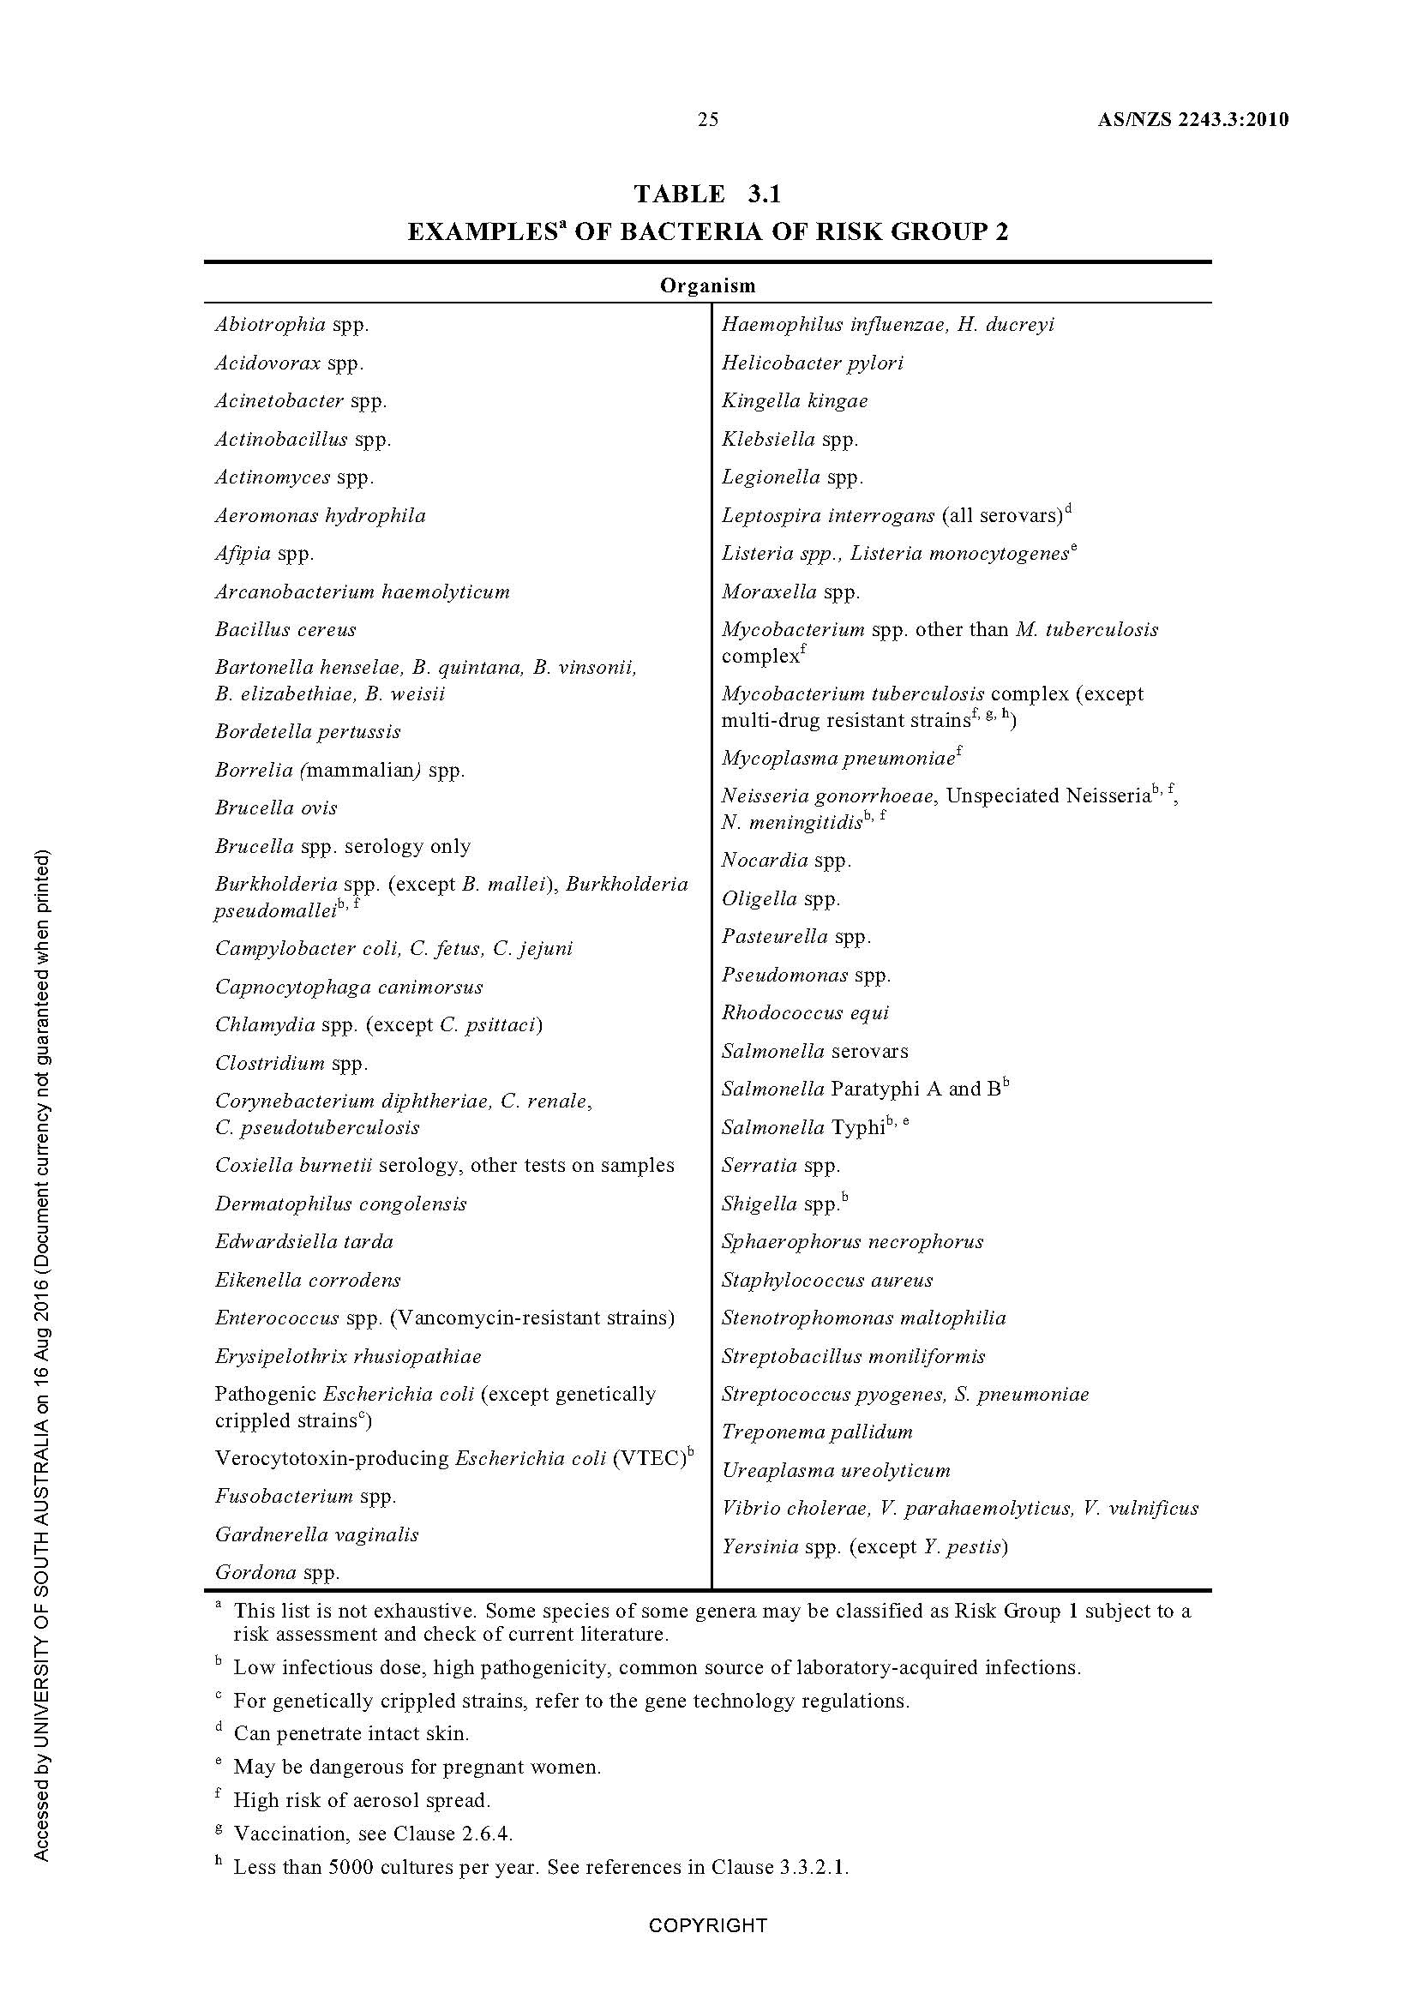
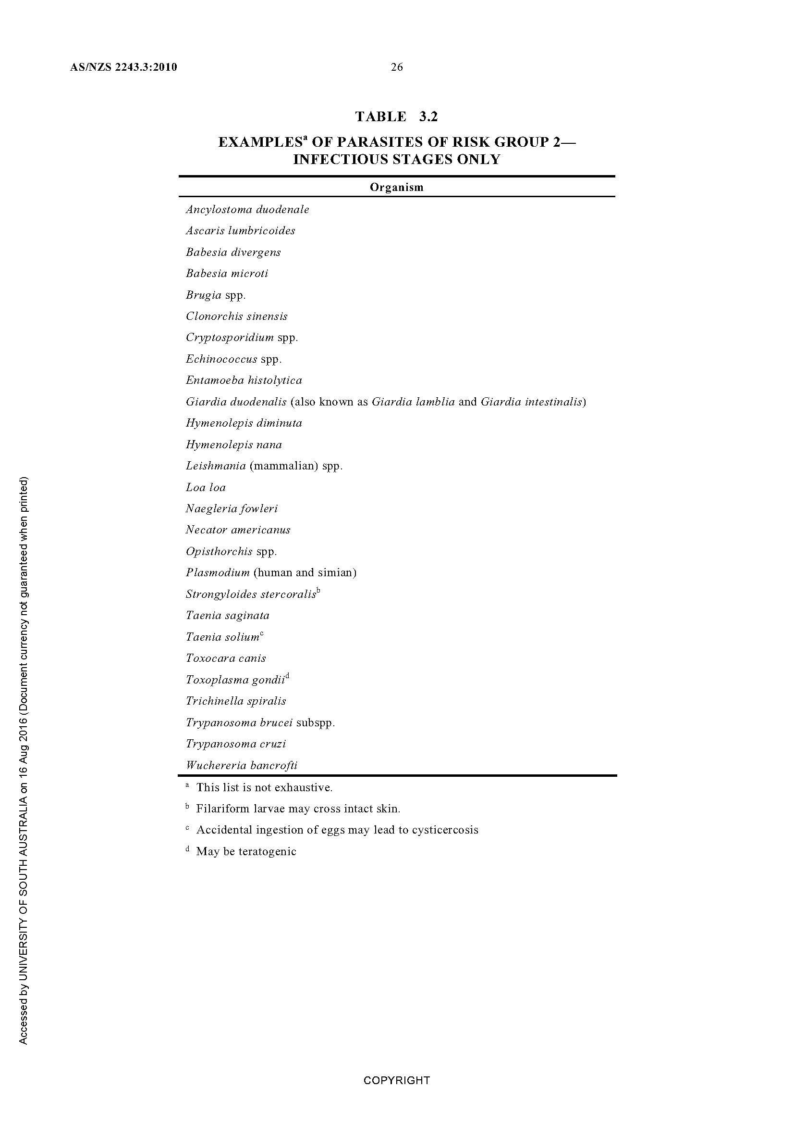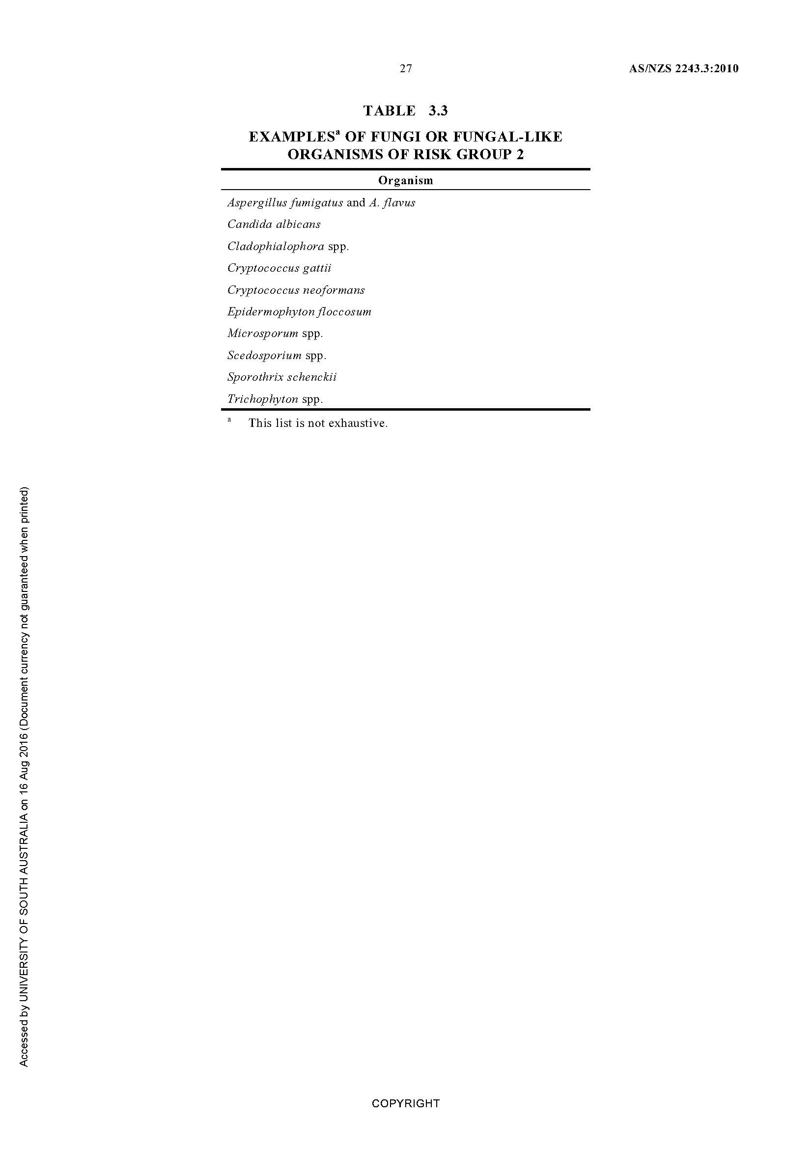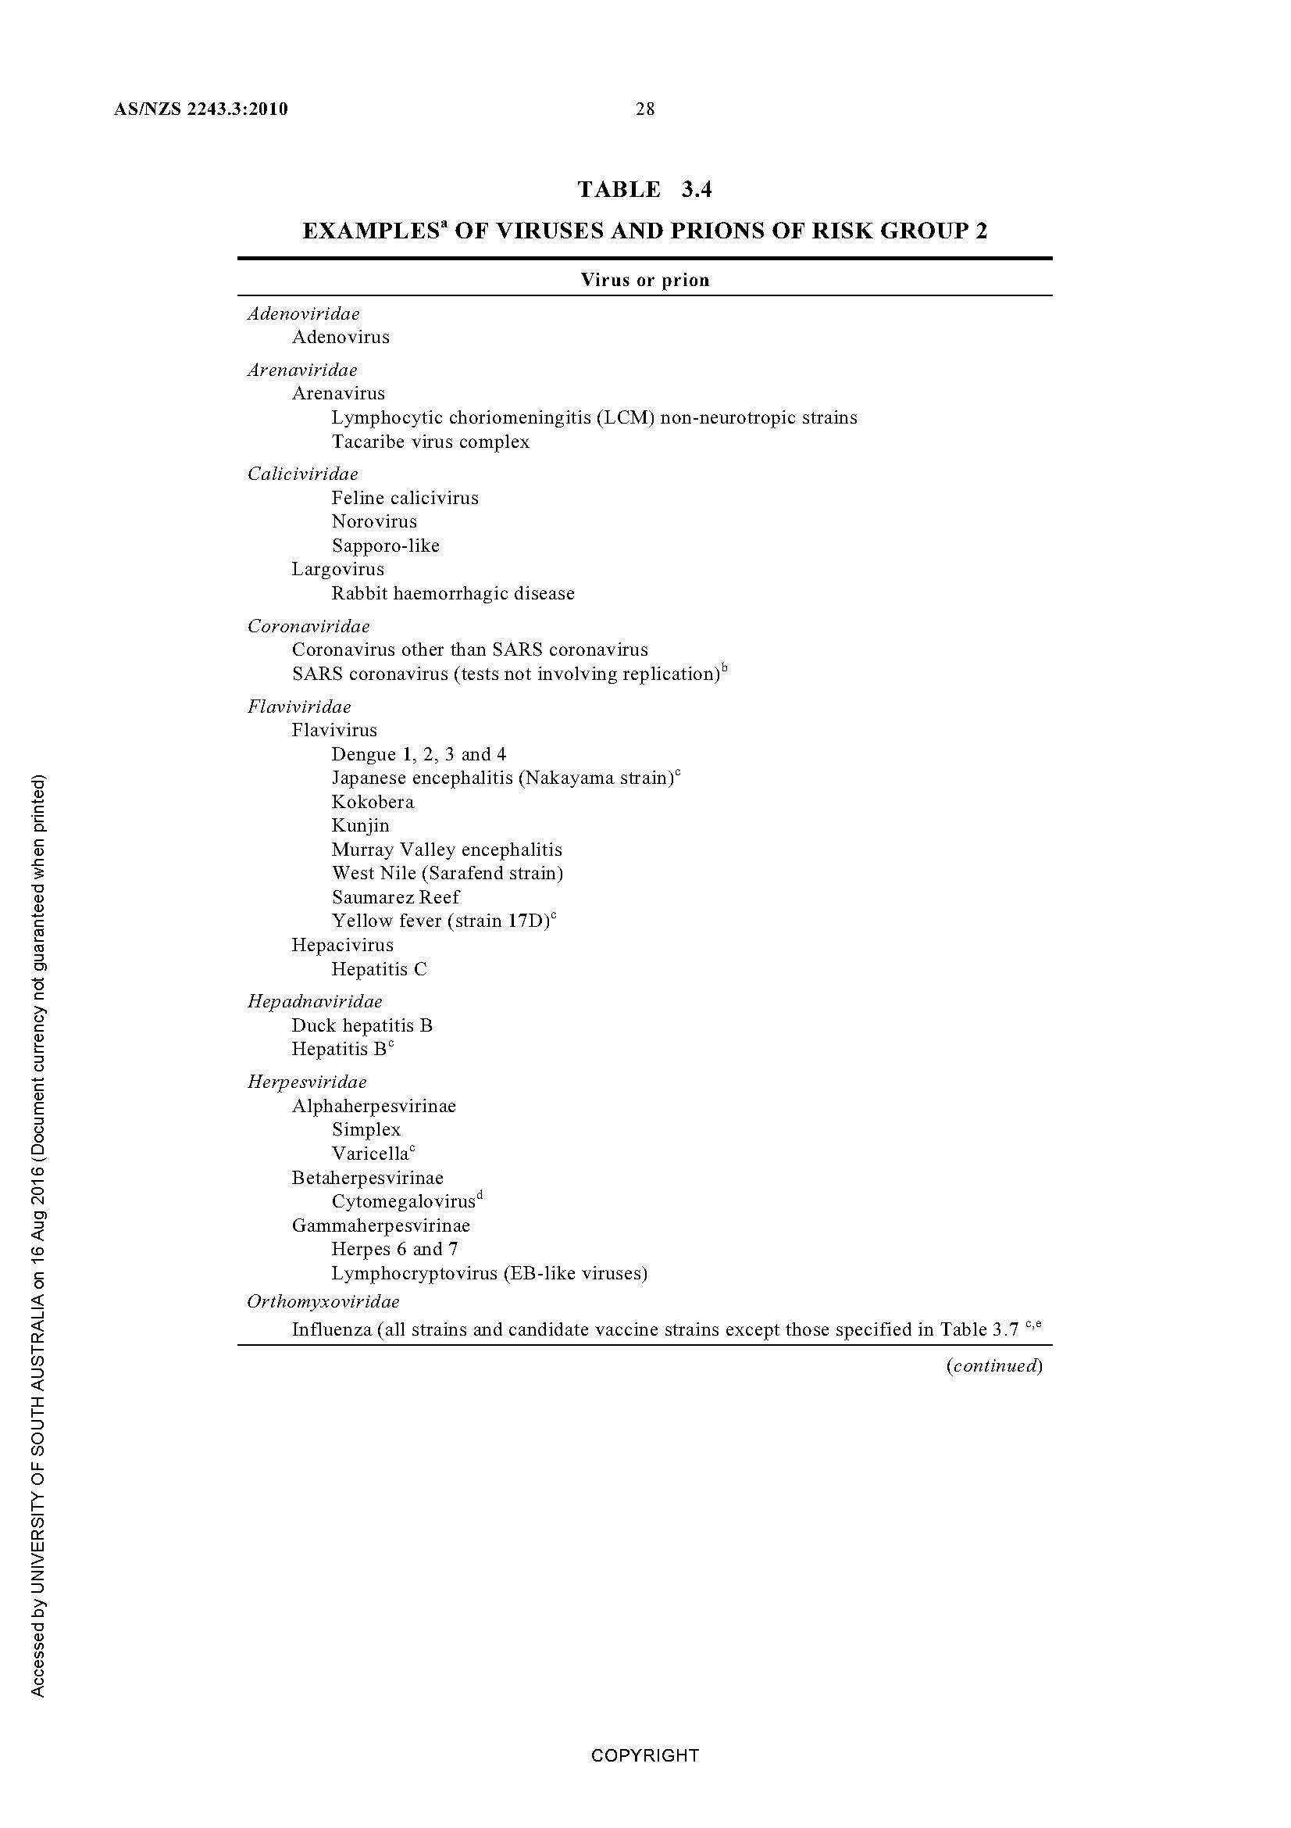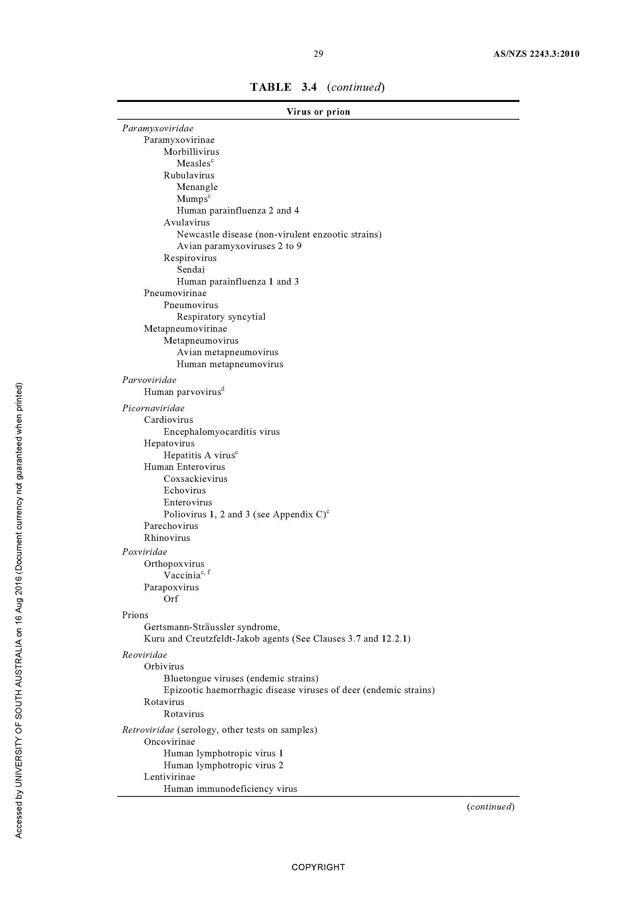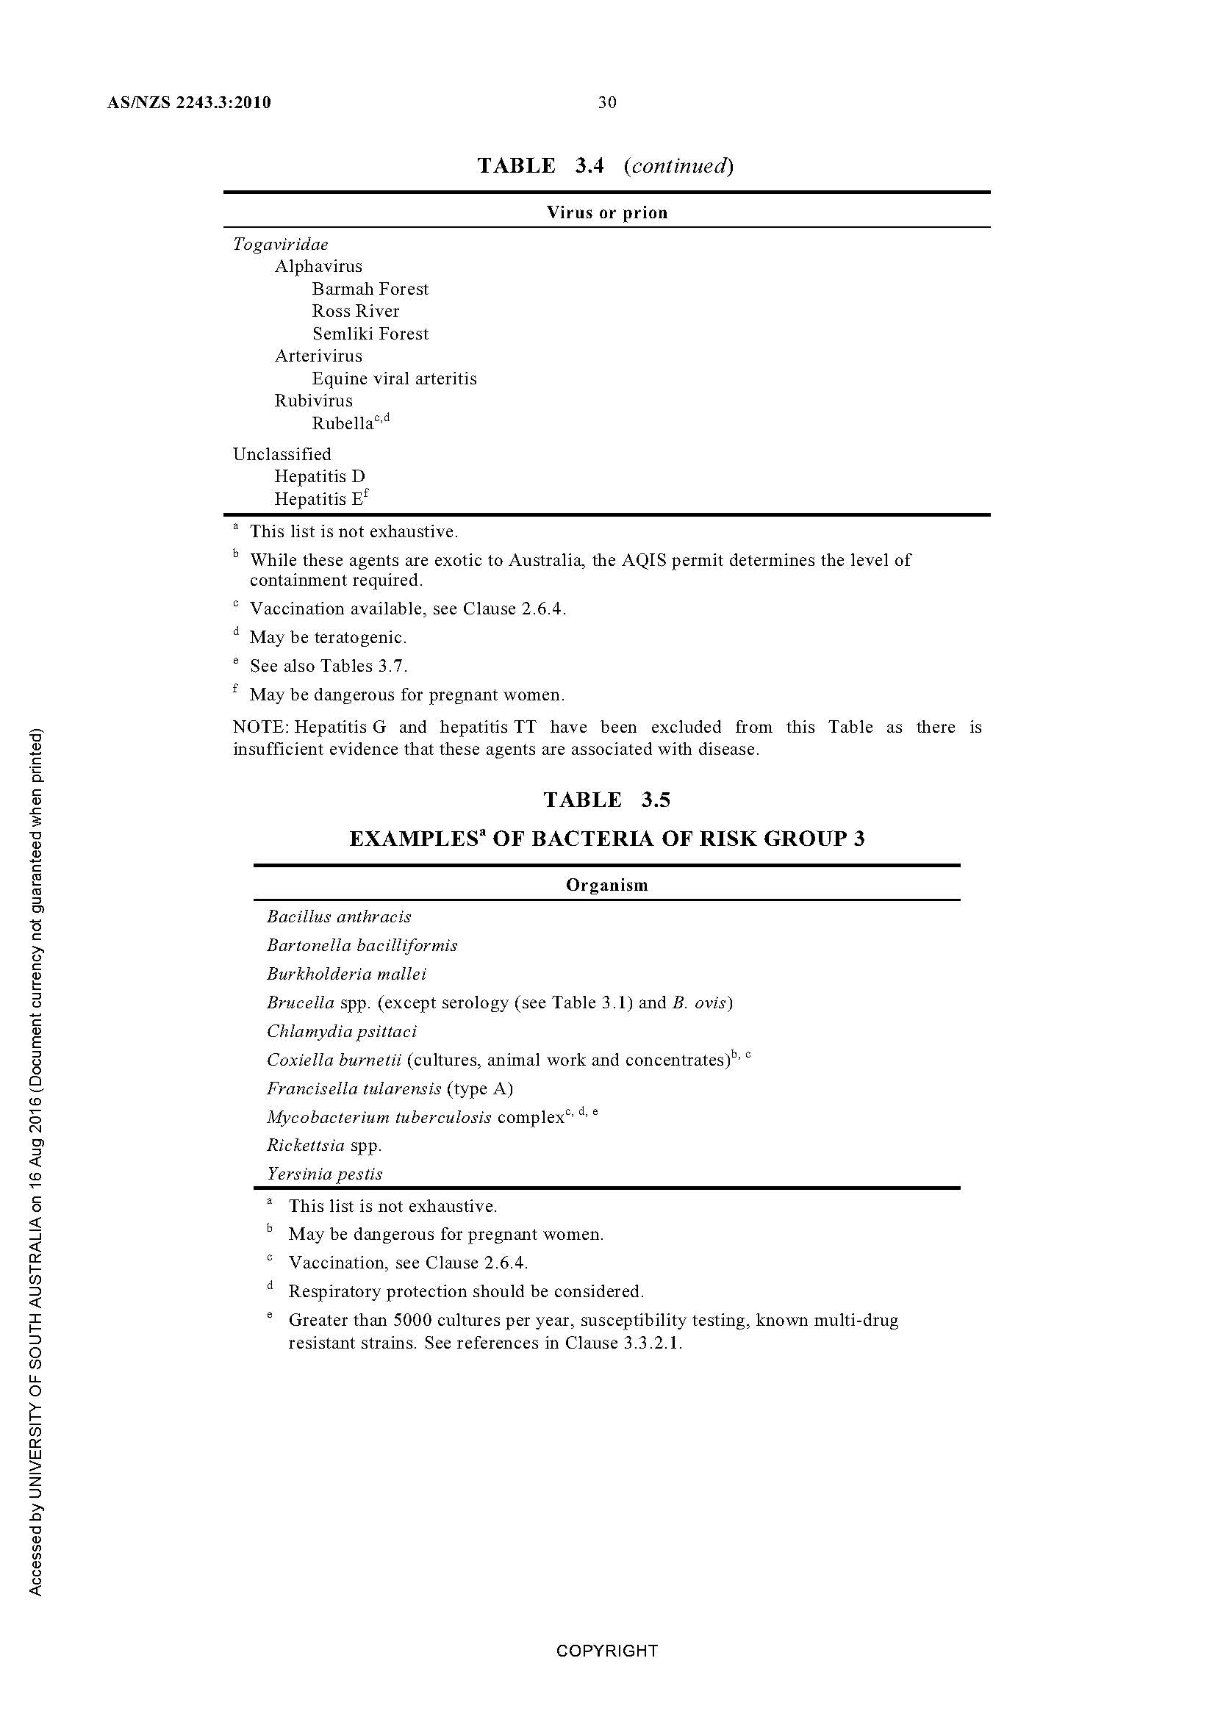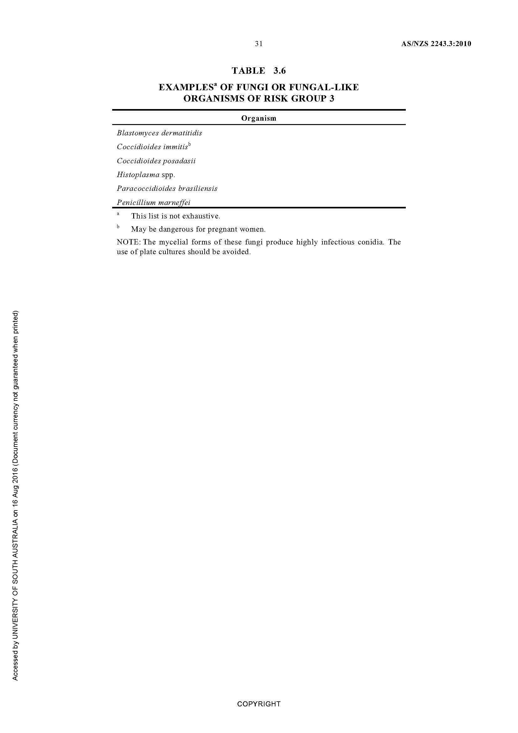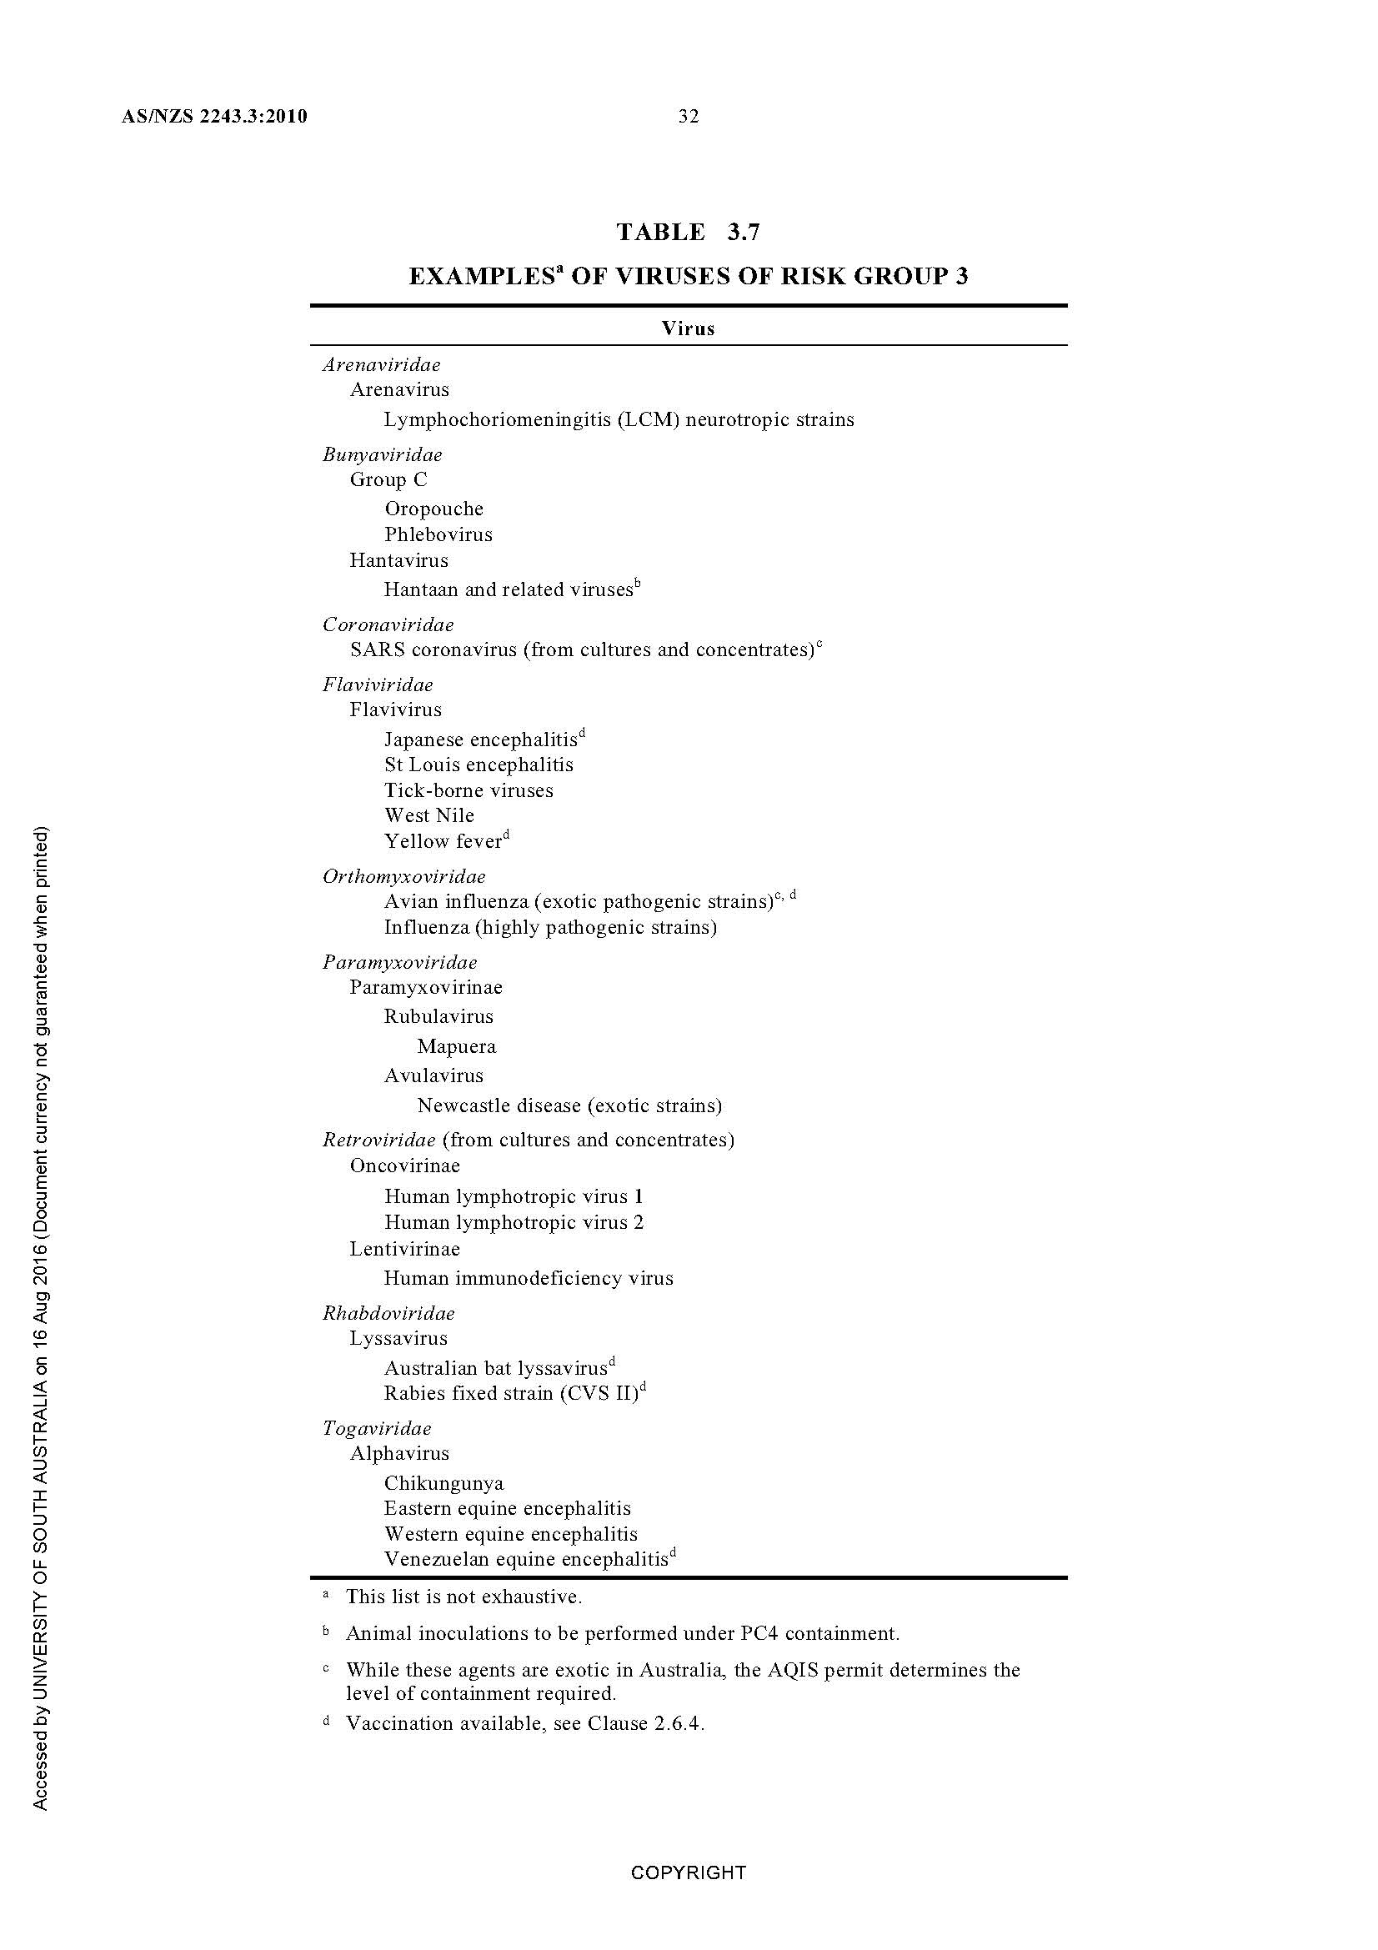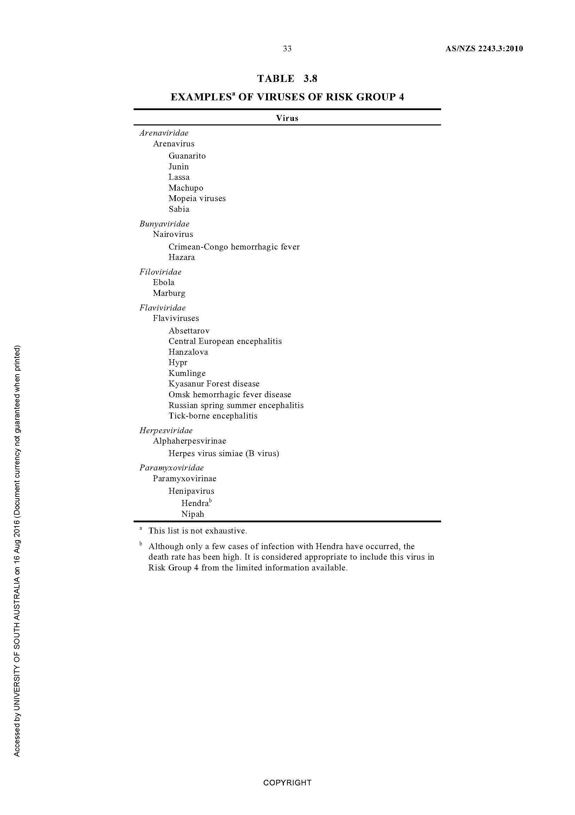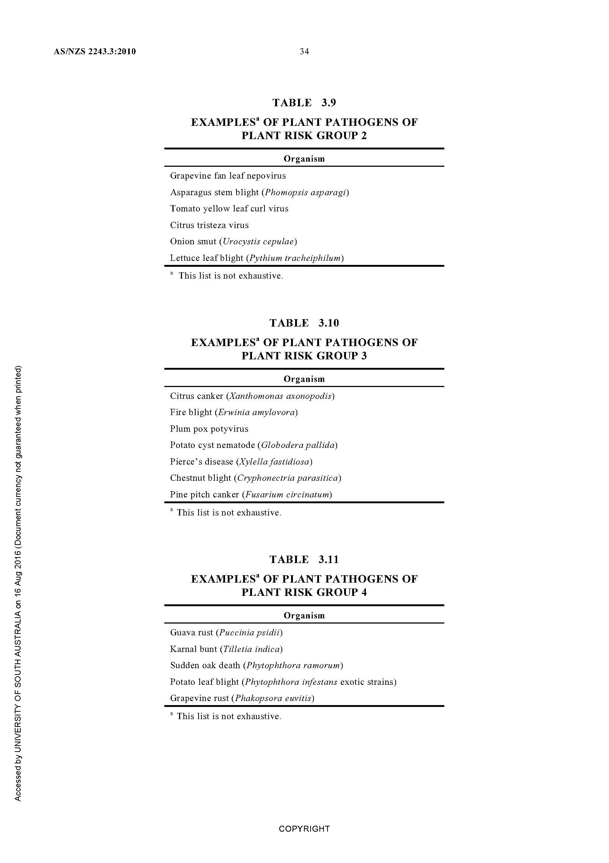
Appendix 2
Required Approvals for Biologicals

Biological solely consist of:
a) purified or synthesised inert DNA, RNA or protein, or
b) a substance neutralized or inactivated, or
c) bodily fluids dried on absorbent material, or
d) material collected for transfusion or transplantation

none of which is not being used for gene technology?

Genetically Modified?

No IBC Application Required

Submit GMO Application to IBC

Classified as
Containment Level 1 or
Not Biologically hazardous?

Submit
Biological Hazard Application
To IBC
No IBC Application Required

Appendix 3
Techniques That Are Not Gene Technology
Item | Description of technique
1 | Somatic cell nuclear transfer, if the transfer does not involve genetically modified material.
2 | Electromagnetic radiation-induced mutagenesis.
3 | Particle radiation-induced mutagenesis.
4 | Chemical-induced mutagenesis.
5 | Fusion of animal cells, or human cells, if the fused cells are unable to form a viable whole animal or human.
6 | Protoplast fusion, including fusion of plant protoplasts.
7 | Embryo rescue.
8 | In vitro fertilisation.
9 | Zygote implantation.
10 | A natural process, if the process does not involve genetically modified material.  Examples: Examples of natural processes include conjugation, transduction, transformation and transposon mutagenesis.
11 | Introduction of RNA into an organism, if:  (a) the RNA cannot be translated into a polypeptide; and  (b) the introduction of the RNA cannot result in an alteration of the organism’s genome sequence; and  (c) the introduction of the RNA cannot give rise to an infectious agent.

Changes to methylation of genomic deoxyribonucleic acid (DNA) by RNA introduction are not considered an alteration of an organism’s genome sequence.

Organisms That Are Not Genetically Modified Organisms
An organism is not a genetically modified organism if:
(a) one or more items in Schedule 1 applies to the organism; and
(b) the organism has not been modified by gene technology except for any modifications described in those items; and
(c) the organism has not inherited any traits from an organism (the initial organism), being traits that occurred in the initial organism because of gene technology, except as described in item 9 in Schedule 1; and
(d) none of the items in Schedule 1B applies to the organism.
This means: The organism has neither had its genome modified by oligonucleotide-directed mutagenesis; nor
been modified by repair of single-strand or double-strand breaks of genomic DNA induced by a site-directed nuclease, if a nucleic acid template was added to guide homology-directed repair

Schedule 1
Item | Description of organism
1 | A mutant organism in which the mutational event did not involve the introduction of any foreign nucleic acid (that is, non-homologous DNA, usually from another species).
2 | A whole animal, or a human being, modified by the introduction of naked recombinant nucleic acid (such as a DNA vaccine) into its somatic cells, if the introduced nucleic acid is incapable of giving rise to infectious agents.
3 | Naked plasmid DNA that is incapable of giving rise to infectious agents when introduced into a host cell.
6 | An organism that results from an exchange of DNA if:  (a) the donor species is also the host species; and  (b) the vector DNA does not contain any heterologous DNA.
7 | An organism that results from an exchange of DNA between the donor species and the host species if:  (a) such exchange can occur by naturally occurring processes; and  (b) the donor species and the host species are micro-organisms that:  (i) satisfy the criteria in AS/NZS 2243.3:2010 for classification as Risk Group 1; and  (ii) are known to exchange nucleic acid by a natural physiological process; and  (c) the vector used in the exchange does not contain heterologous DNA from any organism other than an organism that is involved in the exchange.
8 | An organism that is descended from a genetically modified organism (the initial organism), if none of the traits it has inherited from the initial organism are traits that occurred in the initial organism because of gene technology.
9 | An organism that has inherited particular traits from an organism (the initial organism), being traits that occurred in the initial organism because of gene technology, if:  (a) the initial organism was not a genetically modified organism (because of the application of regulation 5); or  (b) all such inherited traits are traits that occurred in the initial organism as a result of a modification described in an item in this Schedule.
10 | An organism that was modified by gene technology but in which the modification, and any traits that occurred because of gene technology, are no longer present.
11 | Agrobacterium radiobacter strain K1026.
12 | Pasteurella multocida strain PMP1.

