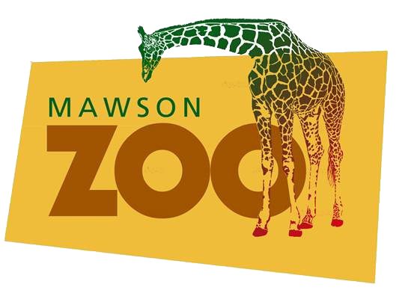
Welcome to the Mawson Zoo Relocation Project!
By following this fictitious project through its lifecycle, you will learn to apply recognised project management processes and techniques.
The video storyline aligns with the weekly learning objectives and activities, to progressively bring to life the core concepts of the subject.
View the ZOO Relocation videos part 1 to part 11 in YouTube playlist:
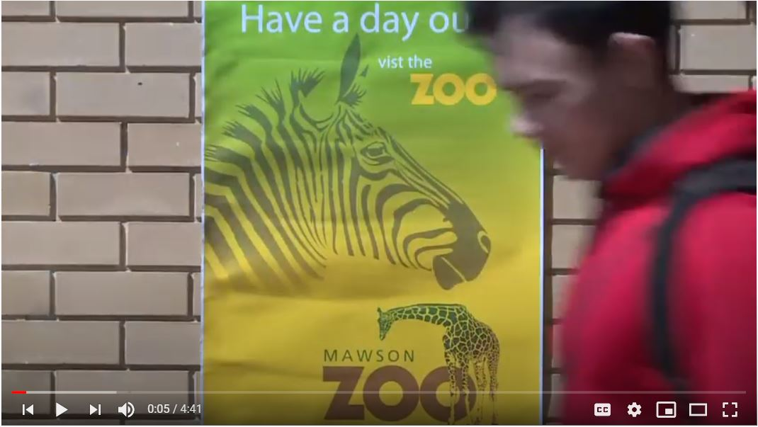
https://www.youtube.com/watch?v=qOTEsSnRgE0&list=PLFcHiIZ7WONM8PYGZSVd3V1blrS60vnYc

Case Study Overview – 2019 Update
Mawson Zoo is a fictitious organisation whose purpose is to advance discovery, understanding and stewardship of the natural world through compelling exhibition and interpretation of living animals.
Strategic Framework
Mawson Zoo operates within a strategic framework that aims to:
1. Maintain engaging animal exhibits, public facilities, gardens, infrastructure and systems to the highest possible standards
2. Provide messages and experiences which inspire visitors to take action to conserve wildlife and build understanding and respect for wildlife
3. Deliver sustainable and ethical practices in our operations, showcasing environmental management and good governance
4. Deliver programs and services which make best use of the funds available and maximise revenue generation for ZOO
5. Ensure the highest possible standards of regional and global species management plans, animal welfare standards and species’ conservation
6. Support wildlife conservation projects using the expertise of ZOO staff, community fundraising and partnering
7. Undertake research and teaching to increase understanding of wildlife conservation and the ZOO’s operations
8. Undertake breeding programs which directly contribute to species conservation and release to the wild programs

Organisational Structure
Mawson Zoo operates within a ‘weak matrix’ structure in which power and influence are largely retained by functional managers within the following divisions:
• Finance & Corporate Services
• Conservation Education & Wildlife
• Public Relations and Community Engagement
• Facilities and Services
• Marketing & Sponsorships

Project Management Maturity
The Zoo recognises Project Management as a serious discipline and values having consistent terminology, tools, and techniques is critical to successful project implementation. The PMO has been very effective at the tactical level, i.e. elevating the organisation’s project management maturity to a level at which the 5th edition of the PMBOK® Guide (PMI 2013) was broadly accepted across the organisation as the standard by which projects are undertaken.
However, the Zoo recognises ‘programs’ in terms of operational activities such as educational programs, and wildlife treatment and research programs.
A further challenge for the zoo is that its’ projects tend to be conceived and implemented in a somewhat isolated fashion, where control and coordination often falls within a single organisational division. As such, projects are rarely prioritised or evaluated with reference to the overall organisational strategy.
The Zoo Operations Manager has recently been given approval to develop and implement an organisation-wide Portfolio / Program / Project (PPP) framework for consideration by the Zoo Executive.
Related Documents
1. Strategic Plan
2. Organisation Chart
3. Zoo Relocation Project; Stage 3 Scoping Document

