 |  | WHS FORM |  |  |  |  |  |  | WHS29

WORKING FROM HOME

WORK HEALTH AND SAFETY SELF-ASSESSMENT FOR STAFF

NOTE: This form supports the WHS Procedure: Working from Home – Health and Safety Considerations.

This checklist is designed to assist staff to set up their work from home arrangement in a safe manner. In completing this you acknowledge the need to cooperate with any reasonable instructions and abide by University policies and procedures while working from home. If you are using University equipment at home, you must record the details on WHS 52A Working from Home – COVID-19 Pandemic Arrangement
Current Workplace: |  |  |  |  |  |  |  | Date:
 | Family name: |  |  | Given name:
 | Contact phone No.(work) (home) (mobile)
 | Position: |  |  |  |  | Manager:
 | Unit/Institute:
 | Address of home-base worksite:
The employee must indicate a Yes or No response to the following (mark N/A if not applicable) and provide a written response where required.
Where a No response is indicated, the employee is responsible to rectify the matter or discuss a reasonable solution with their manager.
 | CHECK ITEMS |  |  |  | YES | NO | ACTIONS REQUIRED / COMMENTS
 | WorkSITE Environment
 | Is the lighting adequate for the task being performed |  |  |  | ☐ | ☐
 | Are noise levels conducive to working effectively without distraction? |  |  |  | ☐ | ☐
 | Is the temperature and airflow comfortable? |  |  |  | ☐ | ☐
 | Is the floor space free of tripping hazards (e.g. electrical cords)? |  |  |  | ☐ | ☐
 | Are smoke detectors installed and suitably maintained? |  |  |  | ☐ | ☐
 | Is your house protected by a circuit breaker and the computer by a surge protector? |  |  |  | ☐ | ☐
 | Are power cords and plugs in good condition? |  |  |  | ☐ | ☐
 | CHAIR/ DESK/WORK SURFACE and EQUIPMENT
 | Is the chair adjustable? (seat height, backrest height and backrest angle). |  |  |  | ☐ | ☐
 | If not, does the chair provide adequate back support e.g. can you rest your back against the chair comfortably in a seated upright or slightly reclined position? |  |  |  | ☐ | ☐
 | Can you get close to the workstation without impediment (If the chair has arms, ensure that they are not in the way and there is clear legroom)? |  |  |  | ☐ | ☐
 | Is the desk/work surface of suitable height in the range of 580-730 mm?
 | Do you require a footrest to support both feet flat on the floor? |  |  |  | ☐ | ☐
 | Is the keyboard directly in front of you and close to the desk/work surface edge and at a comfortable angle? |  |  |  | ☐ | ☐
 | Is the mouse next to the keyboard and can move easily on the surface? |  |  |  | ☐ | ☐
 | Is a document holder required? (For frequent reference to hard copy documents) |  |  |  | ☐ | ☐
 | I have a headset where my tasks involve high volume or lengthy calls |  |  |  | ☐ | ☐
 | When seated and looking straight ahead, is the top edge of the screen at eye level? |  |  |  | ☐ | ☐
 | When seated is the screen at a comfortable reading distance – at least an arm’s length? |  |  |  | ☐ | ☐
 | If using a second monitor is the most frequently used screen directly in front of you? |  |  |  | ☐ | ☐
 | If a laptop computer is used, have you considered a laptop stand/riser and an external monitor, mouse and keyboard? |  |  |  | ☐ | ☐
 | Is the screen positioned away from a window to avoid glare? |  |  |  | ☐ | ☐
 | OTHER
 | Is the WorkPace Ergonomic Software installed to ensure adequate breaks? |  |  |  | ☐ | ☐
 | Are you aware of the University’s incident reporting process? |  |  |  | ☐ | ☐
 | Are emergency contact numbers known including specific University contacts? |  |  |  | ☐ | ☐

Note – If a staff member is unsure of whether their workstation is appropriate for them, or after a period of time they are experiencing discomfort they can contact their WHS Consultant for advice which may include sending a photograph of their workstation to help identify aspects that can be modified.

Employee declaration:
I verify that the information provided in this working from home application is a true and accurate record.
Employee’s signature | Date:
Manager’s Name | Date:
Manager’s Signature
For further health and safety information, contact Safety and Wellbeing team on 8302 2459 or visit the Safety and Wellbeing website.

RECOMMENDED ERGONOMIC WORKSTATION SETUP
Image 1 – Workstation setup – sitting Image 2 - Laptop Use
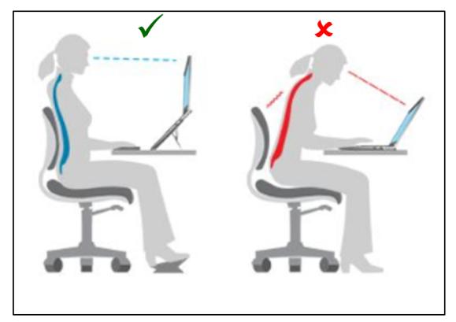

Source – The University of Sydney (Sydney.edu.au)

