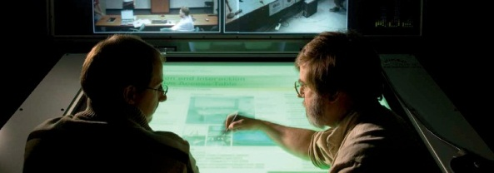
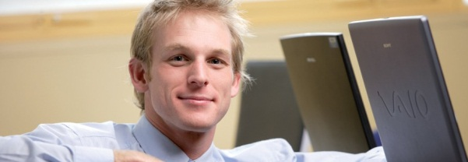

School of Information Technology & Mathematical Sciences
Advanced Computing Research Centre
Summer Vacation Scholarship
Application Form

Personal details
Full Name:
Student ID:
Program:
Year level:
Preferred email:

Project title / nominated research area
Please nominate up to three potential research projects in order of preference. If you do not have a specific project in mind, please indicate up to three specific research areas or themes of interest.

Project 1
Project 2
Project 3

Have you discussed any of the above research projects with a potential ITMS Supervisor? Y / N

If yes, who?

Research lab placement preference

Please rank the ACRC labs in order of preference with ‘1’ being your first preference:

 | Data Analytics Group |  |  | Security Lab
 | Health Informatics Lab |  |  | SIM Lab
 | Information Assurance Group |  |  | Systems Architecture Lab
 | Knowledge & Software Engineering Lab |  |  | Wearable Computer Lab
 | Magic Vision Lab

Availability to undertake 10 week placement

Please confirm that you are available to undertake a 10 week research placement between
November and February this coming summer period: Y / N
Provide details of any leave you have planned outside of the standard University closure period between Christmas and the New Year.

Leave dates:

Applicant Signature: |  |  | Date:

Application and selection process

Applications for a Summer Vacation Scholarship close on the 15 October each year.

All applications will be reviewed by a selection panel and candidates will be advised of their application outcome via email.

Please submit your application via:

Email: | ITMSScholarships.enquiries@unisa.edu.au
Post: | Attn: Scholarships  School of Information Technology & Mathematical Sciences  Division of Information Technology, Engineering and the Environment  University of South Australia  GPO Box 2471  Adelaide SA 5001

For further information please contact the School of Information Technology & Mathematical Sciences:

Phone: | (08) 8302 0525 or (08) 8302 3970
Email: | ITMSScholarships.enquiries@unisa.edu.au
Scholarships  website: | http://www.unisa.edu.au/IT-Engineering-and-the-Environment/Information-Technology-and-Mathematical-Sciences/Scholarships-prizes-and-awards1/
ACRC website: | http://www.unisa.edu.au/Research/Advanced-Computing-Research-Centre/

